

Enhanced Uppwise Monitoring & Security Solutions: Azure

White Paper

 UW-ITMOSEC-02

 22/04/24

 **Raunak Sharma**

[**Support@uppwise.com**](mailto:Support@uppwise.com)

 [www.uppwise.com](http://www.uppwise.com)



Mauro Contini

**Ravi P Gupta**

**Luca Paciolla**

**Contents**

1. ABSTRACT 4

2. Introduction 4

2.1 Overview of the Problem or Topic Being Addressed 4

2.2 Purpose of the White Paper 4

2.3 Importance of the Topic 4

2.4 Outline of What Will Be Covered 4

3. Background/Problem Statement 4

3.1 Detailed Explanation of the Problem or Issue Being Addressed 5

3.2 Relevant Background Information to Provide Context 5

3.3 Data or Statistics Supporting the Existence or Significance of the Problem 5

4. Implemented Solution & Approach 6

4.1 Description of the Conducted Solution or Approach 6

4.1.1 Unified Monitoring and Security Platform: 6

4.1.2 Advanced Threat Detection and Response: 6

4.1.3 Continuous Compliance Monitoring: 6

4.1.4 Scalable and Flexible Architecture: 7

4.2 Explanation of How it Addresses the Identified Problem 7

4.3 Unique Features or Advantages of the Implemented Solution 7

5. Challenges and Risks 7

5.1 Identification of Potential Challenges or Obstacles to Implementation: 7

5.1.1 Complexity of Integration: 7

5.1.2 Skills Gap: 7

5.1.3 Compliance Requirements: 7

5.2 Assessment of Associated Risks: 7

5.2.1 Data Breaches: 7

5.2.2 Cyber Attacks: 7

5.2.3 Compliance Violations: 7

5.3 Mitigation Strategies: 7

5.3.1 Comprehensive Security Planning and Implementation: 7

5.3.2 Continuous Monitoring and Threat Detection: 8

5.3.3 Employee Training and Awareness: 8

5.3.4 Internal Security Operations Center (SOC): 8

6. Strengthening Uppwise Azure Infrastructure: Integrated Monitoring and Security Solution 8

6.1 Importance of Integrating Monitoring and Security: 8

6.2 Microsoft Defender for Cloud and Azure Monitor Integration: 8

6.3 Azure Policy and Governance: 8

7. Comprehensive Architectural Diagram: Implemented Integrated Monitoring and Security Solution 9

8. Exploring Azure Monitoring Services: Components Overview 10

8.1 Azure Monitor Overview: 10

8.1.1 Azure Monitor Metrics: 10

8.1.2 Azure Monitor Logs: 10

8.1.3 Azure Application Insights: 10

8.1.4 Azure Log Analytics: 10

8.1.5 Azure Network Watcher: 10

8.1.6 Azure Advisor: 10

8.2 Best Practices for Monitoring in Azure: 10

9. Exploring Azure Security Services: Components Overview 11

9.1 Microsoft Defender for Cloud: 11

9.2 Azure Key Vault: 11

9.3 Azure Security Features: 11

9.4 Azure Active Directory (Azure AD): 11

9.5 Azure Policy: 11

9.6 Azure Resource Manager (ARM) Security: 11

9.7 Best Practices for Security in Azure: 11

10. Compliance Fulfillments along with Microsoft Defender Benchmarks & Security Score 11

11. Future Trends and Considerations 12

11.1 Emerging Technologies and Trends in Azure Monitoring and Security: 12

11.2 Predictions for the Future of Monitoring and Security in Azure: 12

11.3 Recommendations for Staying Ahead of Evolving Threats: 12

12. Conclusion: 13

12.1 Summary of Key Points: 13

12.2 Importance of Continuous Monitoring and Security in Azure: 13

12.3 Encouragement for Further Exploration and Implementation of Azure Monitoring and Security Services: 13

13. RFI FAQs: Common Queries Addressed for Information Gathering 14

# ABSTRACT

The white paper **"Enhanced Uppwise Monitoring and Security Solutions: Azure"** explores key aspects of securing and monitoring Uppwise's cloud environments on Azure. It examines Azure's services and tools tailored for this purpose and proposes strategies for risk mitigation and defense reinforcement. The paper offers practical insights and best practices to empower organizations in safeguarding their cloud environments, ensuring the protection of critical assets and business continuity.

# Introduction

The migration to cloud computing, particularly within Azure environments, has become prevalent among organizations seeking scalability, flexibility, and cost-effectiveness. However, this transition presents challenges in monitoring and security. The white paper aims to address these challenges and propose effective strategies.

## 2.1 Overview of the Problem or Topic Being Addressed

As UPPWISE embraces Azure for its infrastructure needs, it encounters complexities in ensuring robust monitoring and security. The dynamic nature of Azure's infrastructure and evolving threats pose challenges, requiring comprehensive solutions tailored to Azure's architecture.

## 2.2 Purpose of the White Paper

The primary purpose is to provide stakeholders with an understanding of the challenges in monitoring and securing Azure environments. By elucidating these challenges and offering insights, the paper aims to empower organizations to enhance their Azure monitoring and security posture effectively.

## 2.3 Importance of the Topic

The importance of prioritizing Azure monitoring and security cannot be overstated. Inadequate measures can expose organizations to risks, including data breaches and service interruptions. By prioritizing Azure monitoring and security, organizations can mitigate these risks and maintain stakeholder trust.

## 2.4 Outline of What Will Be Covered

The white paper will cover various aspects related to enhancing Azure monitoring and security solutions. It will delve into challenges, explore best practices, and highlight the role of advanced Azure monitoring tools. Additionally, it will provide practical insights and actionable recommendations.

# Background/Problem Statement

The rise of cloud computing, particularly in Azure environments, has transformed organizational infrastructure operations. However, it has also brought forth challenges, notably the need for robust monitoring and security solutions.

## 3.1 Detailed Explanation of the Problem or Issue Being Addressed

Ensuring data integrity, confidentiality, and availability within Azure environments is crucial. However, Azure's dynamic infrastructure, scalability, and diverse services pose challenges for effective monitoring and security. Traditional approaches often fall short in addressing Azure's unique requirements, leading to gaps in visibility and threat detection.

## 3.2 Relevant Background Information to Provide Context

The widespread adoption of Azure signifies its benefits in scalability and cost-effectiveness. Yet, it also means increased exposure to cyber threats due to the hosting of sensitive data and workloads. Regulatory requirements add complexity to Azure monitoring and security efforts.

## 3.3 Data or Statistics Supporting the Existence or Significance of the Problem

Recent reports indicate a significant increase in cyberattacks targeting cloud environments, including Azure. Organizations face challenges in identifying and responding to breaches promptly. These statistics highlight the importance of prioritizing Azure monitoring and security to mitigate risks.

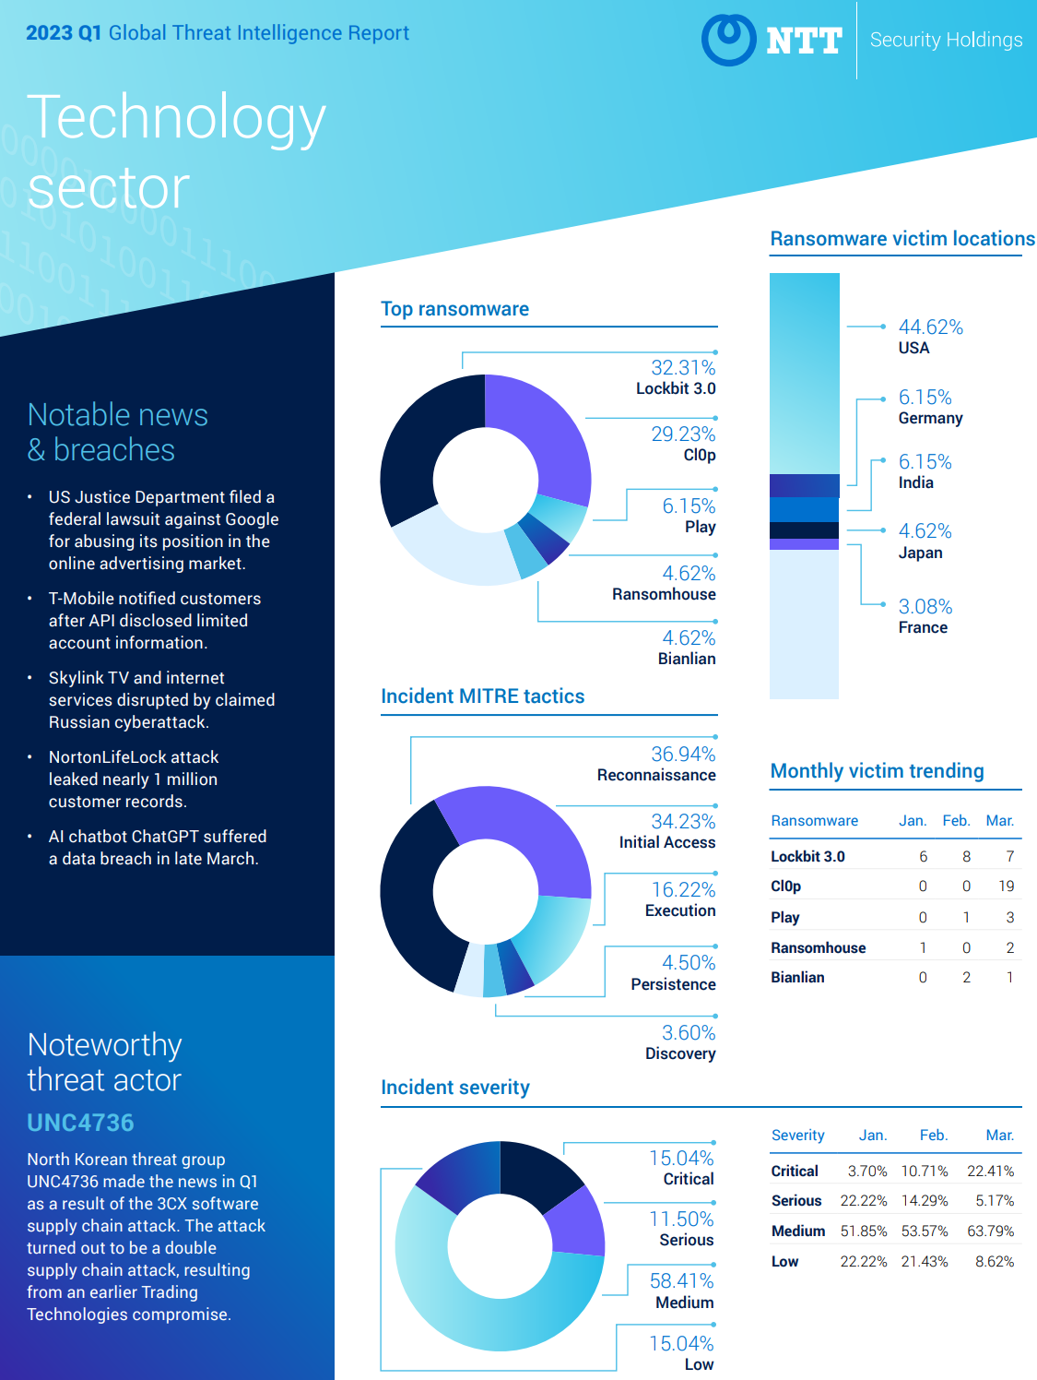

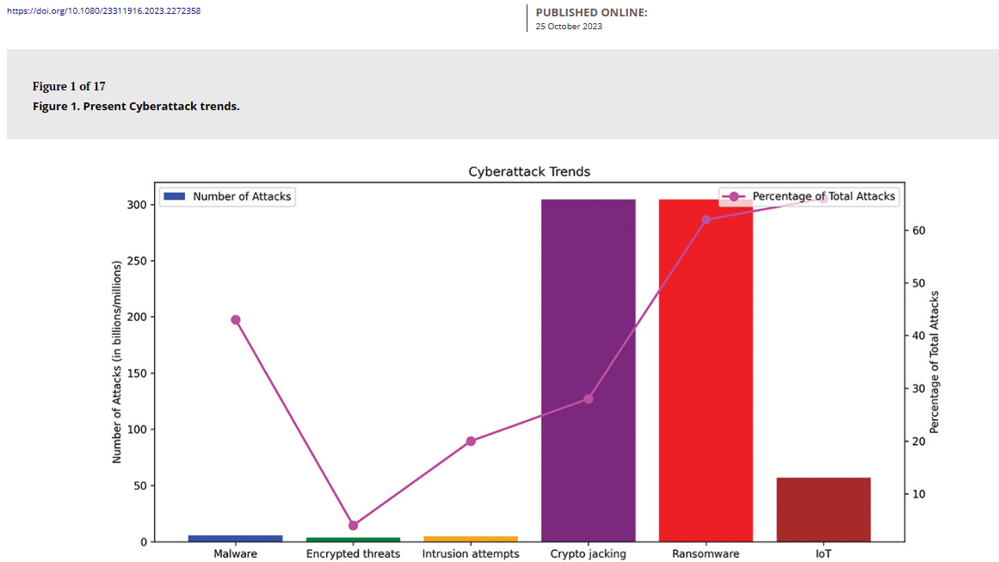

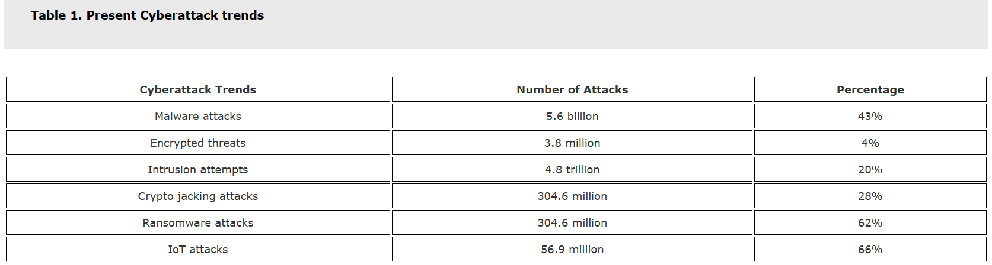

# Implemented Solution & Approach

To address challenges in Azure monitoring and security, we proposed a comprehensive solution leveraging native Azure tools and best practices.

## 4.1 Description of the Conducted Solution or Approach

Our solution encompasses:

### 4.1.1 Unified Monitoring and Security Platform:

Implementing a platform integrating native Azure tools for centralized visibility and control over resources.

### 4.1.2 Advanced Threat Detection and Response:

Deploying capabilities for proactive threat hunting and automated incident response.

### 4.1.3 Continuous Compliance Monitoring:

Implementing automated compliance checks and remediation workflows to ensure adherence to standards.

### 4.1.4 Scalable and Flexible Architecture:

Designing an architecture to accommodate the dynamic nature of Azure environments.

## 4.2 Explanation of How it Addresses the Identified Problem

The solution provides centralized visibility and control, enhances threat detection and response, ensures compliance, and offers scalability.

## 4.3 Unique Features or Advantages of the Implemented Solution

Integration with native Azure tools and third-party solutions, advanced threat detection and response capabilities, continuous compliance monitoring, and a scalable architecture are key advantages of our solution.

# 5. Challenges and Risks

## 5.1 Identification of Potential Challenges or Obstacles to Implementation:

### 5.1.1 Complexity of Integration:

Integrating Azure monitoring and security services into existing infrastructure can be complex and time-consuming.

### 5.1.2 Skills Gap:

Finding and retaining qualified professionals with expertise in cloud security and threat detection can be challenging.

### 5.1.3 Compliance Requirements:

Ensuring security configurations align with regulatory standards can be resource-intensive.

## 5.2 Assessment of Associated Risks:

### 5.2.1 Data Breaches:

Misconfigurations in Azure services can lead to unauthorized access and data breaches.

### 5.2.2 Cyber Attacks:

Vulnerabilities in Azure infrastructure may lead to cyber-attacks, disrupting operations.

### 5.2.3 Compliance Violations:

Non-compliance with regulations can result in legal penalties and reputational damage.

## 5.3 Mitigation Strategies:

### 5.3.1 Comprehensive Security Planning and Implementation:

Risk Assessment: Identify security threats and vulnerabilities within the Azure environment.

Security Controls: Implement preventive, detective, and responsive security controls.

Security Baselines: Establish standard configurations for Azure services based on best practices.

### 5.3.2 Continuous Monitoring and Threat Detection:

Real-time Monitoring: Utilize Azure Monitoring and Security Services for continuous monitoring.

Threat Intelligence: Leverage threat intelligence feeds to identify emerging threats.

Behavioural Analytics: Use analytics to detect anomalous behavior and security breaches.

### 5.3.3 Employee Training and Awareness:

Security Awareness Training: Provide cybersecurity training programs to employees.

Role-based Training: Tailor training programs to employees' roles and responsibilities.

Simulated Phishing Exercises: Conduct exercises to test employees' awareness of phishing threats.

### 5.3.4 Internal Security Operations Center (SOC):

Establish an internal SOC equipped with skilled cybersecurity professionals.

Invest in training programs to upskill existing staff in cybersecurity practices.

# 6. Strengthening Uppwise Azure Infrastructure: Integrated Monitoring and Security Solution

## 6.1 Importance of Integrating Monitoring and Security:

Combining monitoring and security tools is crucial for maintaining Azure environments' integrity, availability, and compliance. It enables proactive threat detection, incident response, and compliance enforcement.

## 6.2 Microsoft Defender for Cloud and Azure Monitor Integration:

Azure Monitor and Microsoft Defender for Cloud integrate seamlessly to provide unified monitoring and security. This integration correlates performance metrics with security events, facilitating proactive threat detection and rapid incident response.

## 6.3 Azure Policy and Governance:

Azure Policy enforces compliance with organizational policies and regulatory requirements. Integrating it with Defender for Cloud and Azure Monitor ensures adherence to security best practices and compliance standards, providing centralized visibility and control.

**In summary, integrating monitoring and security is vital for Uppwise to detect, respond to, and mitigate security threats effectively in Azure environments. Leveraging Azure Monitor, Defender for Cloud, and Azure Policy integration capabilities enables comprehensive visibility, threat detection, and compliance enforcement.**

# Comprehensive Architectural Diagram: Implemented Integrated Monitoring and Security Solution

A sophisticated professional architectural diagram for an integrated monitoring and security solution in UPPWISE on Azure involves illustrating the various components and their interactions.

The architectural diagram shows the integration of monitoring and security components within an Azure environment to provide comprehensive visibility, threat detection, and response capabilities.

It demonstrates how Azure Monitor, Microsoft Defender for Cloud, Azure Policy, and other Azure services work together to ensure the security, compliance, and integrity of Azure resources and applications.



# 8. Exploring Azure Monitoring Services: Components Overview

## 8.1 Azure Monitor Overview:

Azure Monitor provides insights into Azure resources and applications' performance and health through telemetry data collection from various sources. It offers features like metrics, logs, alerts, and dashboards for monitoring and troubleshooting.

### 8.1.1 Azure Monitor Metrics:

Collects and visualizes metrics such as CPU usage and network traffic for real-time resource performance monitoring and optimization.

### 8.1.2 Azure Monitor Logs:

Enables collection, analysis, and visualization of log data from Azure resources and applications using the Kusto Query Language (KQL) for effective troubleshooting.

### 8.1.3 Azure Application Insights:

Monitors web application performance, availability, and usage in real time, facilitating issue identification and diagnosis.

### 8.1.4 Azure Log Analytics:

Offers a flexible log management solution for collecting, analyzing, and visualizing log data from various sources, including third-party applications.

### 8.1.5 Azure Network Watcher:

Facilitates network monitoring, diagnosis, and troubleshooting in Azure, optimizing network performance and security.

### 8.1.6 Azure Advisor:

Provides personalized recommendations for optimizing Azure resources based on best practices and resource usage patterns.

## 8.2 Best Practices for Monitoring in Azure:

* Define clear monitoring goals and requirements aligned with business objectives and SLAs.
* Utilize a combination of Azure monitoring services for comprehensive insights.
* Establish consistent monitoring and alerting policies to proactively detect and respond to issues.
* Leverage automation and scripting for streamlined monitoring setup and maintenance.
* Regularly review and optimize monitoring configurations based on evolving business needs and security requirements.

**By implementing these Azure monitoring services and best practices, our organization effectively monitors and optimizes its Azure resources and applications for performance, availability, and security.**

# 9. Exploring Azure Security Services: Components Overview

## 9.1 Microsoft Defender for Cloud:

A cloud-native application protection platform that combines DevSecOps, CSPM, and CWPP capabilities to protect cloud-based applications from cyber threats and vulnerabilities.

## 9.2 Azure Key Vault:

Cloud service for securely storing and managing cryptographic keys, secrets, and certificates used by cloud applications and services.

## 9.3 Azure Security Features:

Built-in security features like Azure Firewall, DDoS protection, NSGs, and WAF to defend against cyber threats.

## 9.4 Azure Active Directory (Azure AD):

A cloud-based identity and access management service providing authentication, authorization, and identity protection for Azure resources and applications.

## 9.5 Azure Policy:

Enables organizations to define, enforce, and monitor policies for resource configurations and compliance standards within Azure environments.

## 9.6 Azure Resource Manager (ARM) Security:

The management layer provides access control, governance, and deployment management for Azure resources, ensuring secure access and policy enforcement.

## 9.7 Best Practices for Security in Azure:

Guidelines and recommendations include strong identity and access management, network security, data encryption, adherence to security governance principles, Azure security benchmarks, and compliance with ISO 27001 standards.

# 10. Compliance Fulfillments along with Microsoft Defender Benchmarks & Security Score

Uppwise reviews Microsoft Defender for Cloud recommendations daily to maintain a high level of security for its cloud services. Additionally, Uppwise maintains regulatory compliance and adheres to security benchmarks, **including ISO 27001:2013 fulfillment with extended controls ISO/IEC 27017 e ISO/IEC 27018 & General Data Protection Regulation (GDPR)**.

Implementing these Azure security services and best practices ensures robust security measures for Uppwise's Azure resources and applications.

# 11. Future Trends and Considerations

## 11.1 Emerging Technologies and Trends in Azure Monitoring and Security:

1. **Artificial Intelligence and Machine Learning:** Azure will increasingly leverage AI and ML algorithms for advanced threat detection, anomaly detection, and predictive analytics.
2. **Cloud-Native Security Solutions:** Azure will offer specialized security tools for cloud-native architectures and serverless applications.
3. **Extended Detection and Response (XDR):** Azure will integrate XDR capabilities for centralized management of security incidents across hybrid and multi-cloud environments.

## 11.2 Predictions for the Future of Monitoring and Security in Azure:

1. **Convergence of Monitoring and Security:** Azure will integrate monitoring and security functions into unified platforms like Azure Sentinel for comprehensive visibility and control.
2. **Shift towards Cloud-Native Security Architectures:** There will be a focus on cloud-native security architectures to address the unique challenges of cloud environments.
3. **Focus on Threat Intelligence and Threat Hunting:** Azure will prioritize threat intelligence and threat-hunting capabilities for proactive threat detection and response.
4. **Enhanced Compliance and Governance:** Azure will invest in compliance and governance capabilities to help organizations meet regulatory requirements.

## 11.3 Recommendations for Staying Ahead of Evolving Threats:

1. **Continuous Education and Training:** Stay informed about emerging technologies and best practices through continuous education and training programs.
2. **Collaboration and Information Sharing:** Engage with cybersecurity communities and participate in threat intelligence sharing initiatives.
3. **Adopt a Risk-Based Approach:** Prioritize investments and initiatives based on the organization's risk profile and business priorities.
4. **Implement Defense-in-Depth Strategies:** Implement multiple layers of security controls to defend against evolving cyber threats.
5. **Stay Agile and Adaptive:** Embrace agility and adaptability in security operations to respond quickly to changing threats and attack vectors.

By embracing emerging technologies, staying informed about future trends, and adopting proactive security strategies, organizations can effectively protect their Azure environments from cyber threats.

# 12. Conclusion:

In conclusion, implementing Azure monitoring and security services is crucial for organizations aiming to protect their digital assets, mitigate risks, and ensure compliance in today's dynamic threat landscape. Throughout this document, we've delved into various aspects of Azure monitoring and security, covering key features, best practices, real-world examples, and future trends.

## 12.1 Summary of Key Points:

* Azure offers a comprehensive suite of monitoring and security services, including Azure Monitor, Azure Security Center, Azure Sentinel, Azure Key Vault, and Azure Active Directory, all of which is integrated into Uppwise to safeguard its cloud environments.
* Leveraging Azure monitoring and security services enables organizations to gain real-time visibility into their Azure resources, detect and respond to security threats, enforce compliance with regulatory requirements, and enhance operational efficiency.
* Integrating monitoring and security functions into Azure environments empowers organizations to adopt a proactive approach to cybersecurity, automate security operations, and effectively manage risks across hybrid and multi-cloud environments.

## 12.2 Importance of Continuous Monitoring and Security in Azure:

Continuous monitoring and security are vital for a robust cybersecurity strategy in the Cloud. As cyber threats evolve and cloud environments become more complex, organizations must be proactive in identifying and mitigating risks. Continuous monitoring allows real-time detection of security incidents, prompt response to threats, and ensures the integrity of Azure resources and data.

## 12.3 Encouragement for Further Exploration and Implementation of Azure Monitoring and Security Services:

As organizations embrace digital transformation, investing in Azure monitoring and security services becomes imperative. These solutions bolster cybersecurity, mitigate risks, and foster business resilience in the cloud. By prioritizing cybersecurity and leveraging Azure services, organizations can safeguard their digital assets and maintain a competitive edge.

# 13. RFI FAQs: Common Queries Addressed for Information Gathering

1. **What standards does Uppwise adhere to for regulatory and data compliance purposes?**

We are ISO 27001 certified with extended controls ISO/IEC 27017 and ISO/IEC 27018, demonstrating our commitment to information security. In compliance with the General Data Protection Regulation (GDPR), we prioritize data protection and privacy. Additionally, Uppwise conducts daily reviews of Microsoft Defender for Cloud recommendations to uphold robust security benchmarks and regulatory compliance.

1. **What are the data center geographies and compliance standards adhered to within the infrastructure?**

Uppwise cloud applications are hosted in the Azure EU West and North regions, on highly available data centers, with a global uptime average of >99.999%. The primary data center is located in EU West, while the disaster recovery site is located in EU North.

Data Center Certification: Azure data centers operate with the following certificates:



1. **Considerations for PII and GDRP?**

Our Azure infrastructure incorporates robust measures for handling PII and adhering to GDPR. By incorporating the measures, we prioritize data security, privacy, and regulatory compliance, safeguarding sensitive information in alignment with GDPR requirements

1. **How is front-end server security ensured?**

The application server is behind the Built-in security features like Azure Firewall, DDoS protection, network security groups, and network watchers to defend against cyber threats.

1. **How is secure communication ensured between the web server and the database server?**

The communication between the application server and the database server is done with encrypted communication only within the segregated virtual private network.

1. **Does the infrastructure use an Intrusion Detection (IDS) and/or an Intrusion Prevention (IPS) system? how the logging from IDS and IPS is handled procedurally**

Our infrastructure incorporates Microsoft Defender Solution aligned with ISO 27001:2013 and SOC TSP standards, along with security benchmarks. Azure Monitor is enabled for access to audit and activity logs, capturing essential details such as event source, user, timestamps, and more. Continuous logging and monitoring ensure adherence to standard processes and proactive threat detection

1. **Does the infrastructure employ software for regular checks on software versions, settings, active services, and security patches to ensure compliance with defined baselines and update requirements?**

Microsoft Defender systematically checks all baselines, generating alerts with corresponding severity levels to ensure infrastructure maintains up-to-date software and versions, enhancing security and compliance.

1. **Are the servers equipped with current antivirus software actively monitored for various forms of malware, ransomware, and other potential threats?**

Uppwise employs Microsoft Antimalware for Azure, featuring real-time protection to monitor and block malware execution, scheduled scanning, automated malware remediation, and signature updates. Additionally, active protection reports telemetry data to Microsoft Azure for rapid threat response and collects antimalware event logs in the customer's Azure Storage account. Furthermore, Microsoft Defender for Cloud continuously scans cloud resources, identifying and implementing remediations to enhance security and ensure compliance with security standards policies

1. **Does Uppwise employ a hardening process to secure all ICT components against potential attacks?**

We utilize Microsoft Defender for Cloud to continuously assess the security of Azure resources, including network security best practices. DDoS Standard protection is enabled on our Azure Virtual Network to combat DDoS attacks. Azure Monitor provides access to audit and activity logs, capturing critical details. Standard security configurations for network resources are enforced using Azure Policy, with built-in network policy definitions reviewed for network security group implementation. This approach ensures robust protection of our ICT components against potential attacks.

1. **How is data secured and kept secure?**

Our data security measures on Azure encompass encryption, database backups, private VNet communication on secure protocols, and Microsoft Defender for Cloud. We also leverage Azure monitoring tools for logging and analysis. These measures ensure comprehensive protection, maintaining confidentiality, integrity, and availability of our data assets.

1. **How is data encrypted?**

All managed disks, snapshots, images, and data stored on existing managed disks in Azure are automatically encrypted at rest with platform-managed keys. This encryption utilizes 256-bit AES encryption, which is one of the strongest block ciphers available, ensuring compliance with FIPS 140-2 standards. This transparent encryption provides robust protection for data stored within Azure-managed disks

1. **Is encryption required or implemented for data transmission?**

To ensure data security during transit, all outbound traffic from our data centers is encrypted using TLS 1.2, providing strong authentication, message privacy, and integrity. TLS offers interoperability, algorithm flexibility, and ease of deployment, enhancing our security measures for data transmission.

1. **How does the system manage user security for data objects, considering factors like regions, categories, roles, and groups?**

Our solution includes an integrated authorization system that validates users and grants access based on defined permissions for specific data. Our authorization process ensures that only authorized data is processed, mitigating the risk of unauthorized access. We utilize a set of predefined user roles within our policy framework to actively manage user authorization and prevent unauthorized access.

1. **What protocols and ports are specifically required for network-related operations?**

Our servers exclusively employ TLS 1.2 protocols, utilizing best-practice cipher suites to bolster security. We have disabled all TLS/SSL protocols below TLS 1.2 to mitigate vulnerabilities. Additionally, HTTPS-only links are enforced across our applications, complemented by secure site SSL certificates. Furthermore, we have configured HTTP Strict Transport Security (HSTS) on our Internet Information Services (IIS) to further enhance security by ensuring secure connections over HTTPS.